What is the Meet-in-the-Middle (MitM) attack? Definition / Intro
Definition:
A Meet-in-the-Middle attack is a cryptanalytic technique that breaks multiple-encryption schemes (like Double-DES) far faster than naive brute force by exploiting the middle point of the composition. It trades memory for a huge reduction in time complexity.
When used:
Most famously against double-encryption 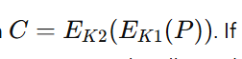If an attacker knows a plaintext–ciphertext pair ((P,C)) they can compute forward encryptions under all possible (K_1) values and backward decryptions under all (K_2) values, and look for matches — meeting in the middle.

🔹 How it works step-by-step (concept)
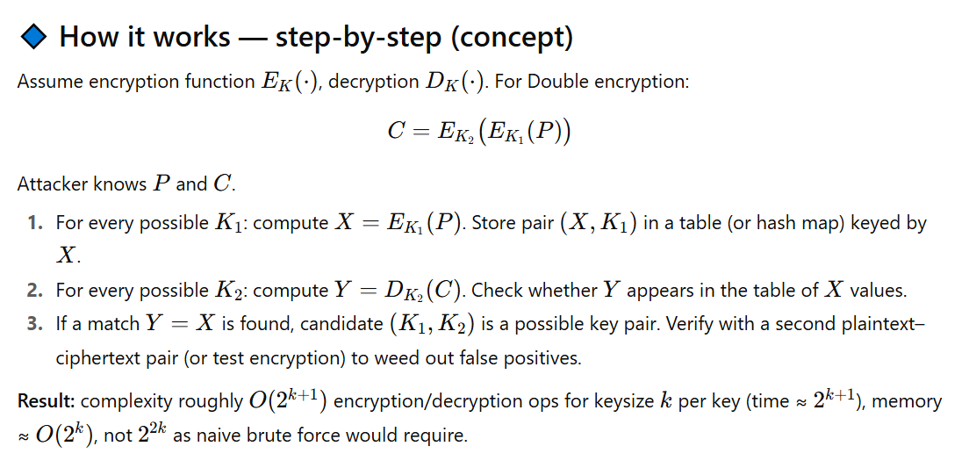
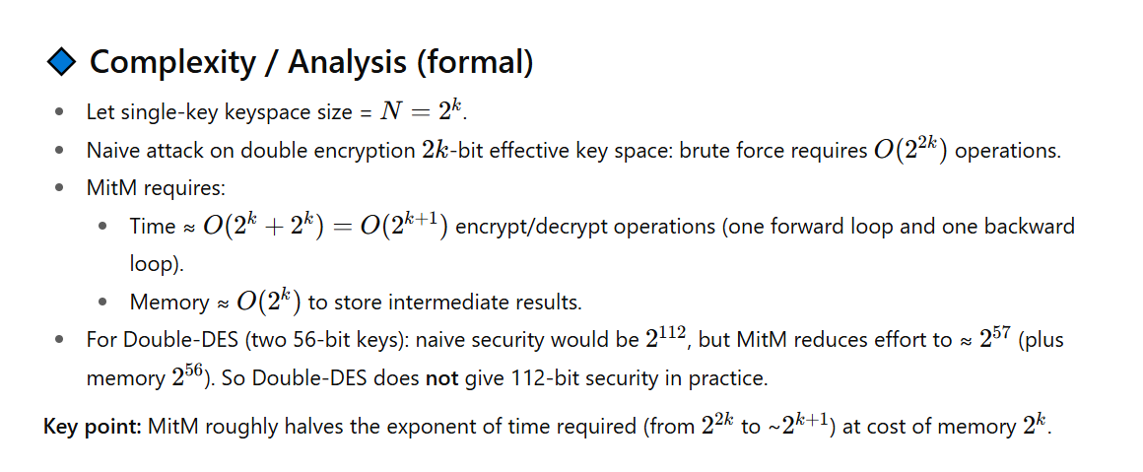

🔹 Toy working example (hand-computable) — tiny keys
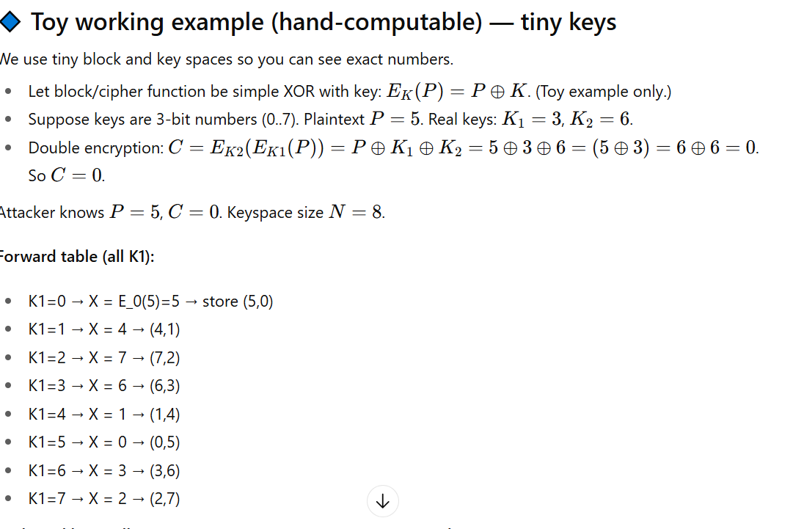Backward loop (all K2): compute Y = D_K2(C) = C ⊕ K2 (XOR decrypt = same):
- K2=0 → Y = 0 → look up 0 → found (0,5) → candidate (K1=5, K2=0)
- K2=1 → Y = 1 → found (1,4) → candidate (K1=4, K2=1)
- K2=2 → Y = 2 → found (2,7) → candidate (K1=7, K2=2)
- K2=3 → Y = 3 → found (3,6) → candidate (K1=6, K2=3)
- K2=4 → Y = 4 → found (4,1) → candidate
- K2=5 → Y = 5 → found (5,0) → candidate
- K2=6 → Y = 6 → found (6,3) → candidate
- K2=7 → Y = 7 → found (7,2) → candidate
We get many candidate pairs — need second plaintext/ciphertext pair to filter to the true pair (K1=3,K2=6) which will confirm.
Conclusion: We tested 8 forward + 8 backward = 16 ops; naive brute force checking all (K1,K2) would require 64 ops.

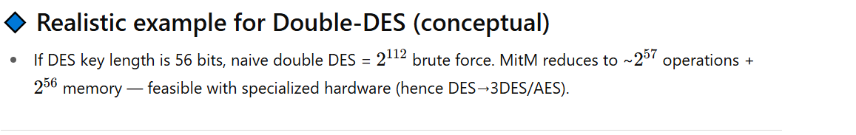

🔹 Pseudocode (practical MitM)
Input: plaintext P, ciphertext C, cipher E/D (black box), keyspace K

// Phase 1: forward table
table = empty map
for k1 in K: // O(|K|)
x = E(k1, P)
table[x] = table.get(x, []) + [k1]

// Phase 2: backward search
candidates = []
for k2 in K: // O(|K|)
y = D(k2, C)
if y in table:
for k1 in table[y]:
candidates.append((k1,k2))

// Verify candidates with additional (P2,C2) if available
return candidates

🔹 Pros and Cons
Pros (for attacker):
- Huge reduction in time vs naive double brute force.
- Straightforward to implement.
- Parallelizable: both forward and backward loops can be distributed.
- Works with only a small number (often 1–2) of known plaintext–ciphertext pairs.
Cons / Limitations (for attacker):
- Requires large memory (O(2^k)). If memory is scarce, time increases.
- Needs ability to evaluate E and D rapidly (access to encryption/decryption oracle or algorithm).
- If keyspace is huge enough and memory unattainable, MitM can still be expensive (but much cheaper than (2^{2k})).
- False positives possible; require verification using another pair.

🔹 Countermeasures / Defenses
To prevent MitM against multiple encryption:
- Use a single strong cipher with sufficiently large key (AES-128/192/256) rather than nesting weaker ciphers.
- Use Triple DES (3DES) with independent keys in EDE mode — MitM against 3DES still expensive (≈(2^{112}) work if keys independent) though there are tradeoffs. (3DES was used because Double-DES is vulnerable.)
- Avoid simple multiple encryption that composes the same cipher twice with independent keys unless you know it resists MitM (many do not).
- Apply authenticated encryption (AEAD) and modern modes to limit oracle access and prevent chosen-plaintext scenarios that make MitM easy.
- Increase key size so that (2^k) memory/time is impractical.
- Use constructions with internal mixing that prevent isolating an intermediate value (i.e., not simple composition (E_{K2}(E_{K1}(\cdot))) that has a clear middle).

🔹 Practical considerations & mitigations in real systems
- Disk / RAM constraints: MitM needs enormous memory for realistic key sizes (e.g., (2^{56}) entries for DES). That’s why specialized hardware was built (EFF cracker). Use AES instead.
- Time–memory tradeoffs: Attacker can lower memory using time–space tradeoffs (e.g., Hellman tables), but that increases time and complexity.
- Multiple plaintexts: Having multiple known plaintext/ciphertext pairs eliminates false positives quickly.

🔹 Conclusion / Short Summary (ready to paste)
Meet-in-the-Middle is a memory-time tradeoff attack that drastically reduces the effective security of naive multiple-encryption schemes (e.g., Double-DES). By computing forward encryptions under all first keys and backward decryptions under all second keys and looking for matches, the attack turns an exponential (2^{2k}) problem into roughly (2^{k+1}) work with (2^k) memory. The MitM attack motivated the move from Double-DES to stronger constructions such as Triple-DES and eventually to AES. Countermeasures include using single modern ciphers with large keys (AES), using 3DES or other constructions designed to resist MitM, and limiting attacker oracle access.

